A short description (1-2 sentences) of the approach you took to your testing.
Because of a lack of time the approach consist of a user perspective. That means all the most common positive paths/happy paths are checked. The rest of the time is for validating most possible negative or unrefined scenarios

A bulleted list of the scenarios you’ve tried, even if they were successful.
- File uploading/removing
  - Uploading files with most popular image extensions (.png, .tiff, .jpg, .bmp, .gif)
  - Uploading multiple files with proper extensions
  - Removing files
  - Uploading most popular document files (.doc, .pdf, .txt)
  - Uploading file with incorrect extension e.g. .exe
  - Uploading improper file with proper extension e.g. putty.jgp (instead of putty.exe)
  - Uploading big sized file (>10MB)
- File previewing/editing and other functionalities
  - All visible functionalities (moving/switching photos, switching pages, zooming, fitting view, smoothing)
  - Hide/show images
  - Printing file
  - Downloading file
  - Sending e-mail
  - Resizing window

A quick description of any bugs you found. It’s OK to not have found any – we’re more interested in your test ideas and approach than what you executed in the 30 minutes.
- Cannot upload .bmp and .gif files
- When there is an error while bad extension file uploading it always shows the same message Could not load images for document.
Could not count the pages of image of extension png.
It says nothing for the user
- After upload improper file with proper extension (e.g. changed putty.exe to putty.png) there is never ending loading gif and the same requests are still sending
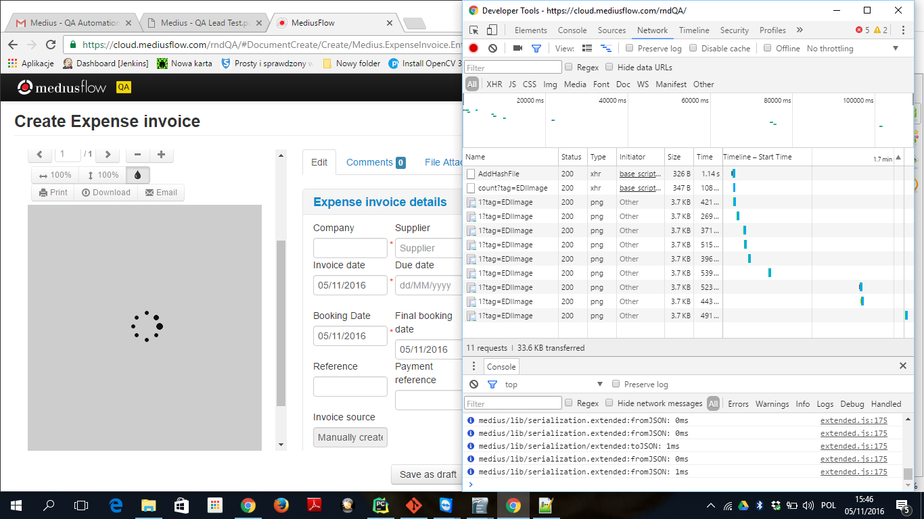
- Downloading converts file to .pdf and decrease resolution dramatically. Additional file name is just a hash name (instead of real file name)
- Image smoothing button is not applied for downloaded files
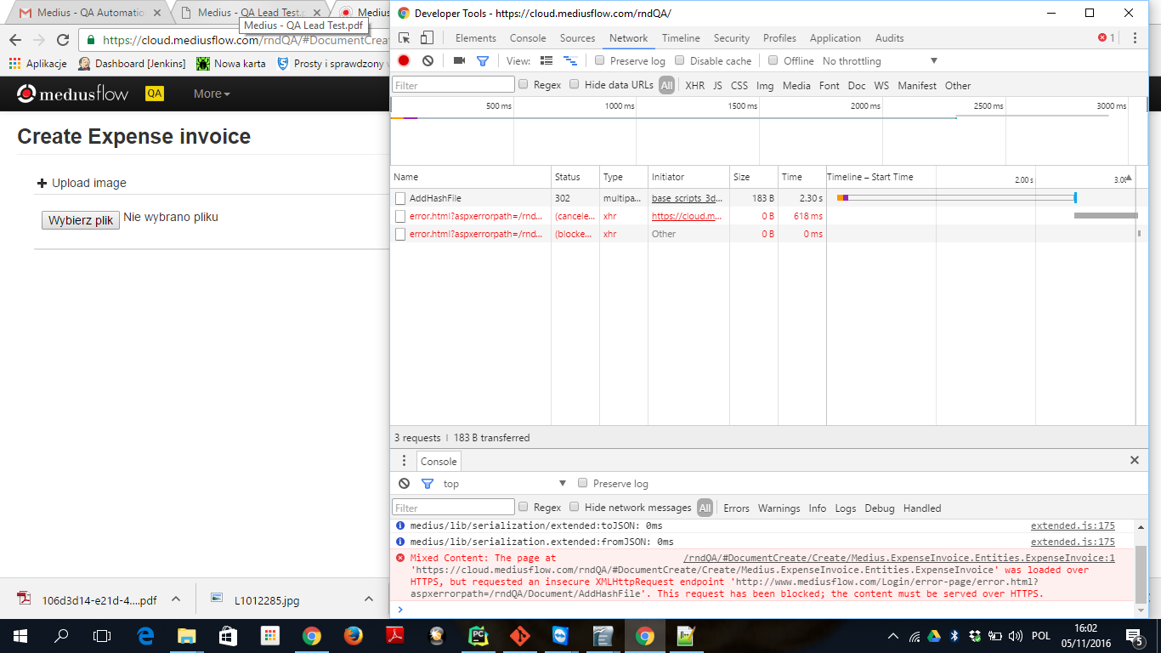
- Files over 10MB cause error. There is no information for the user what went wrong (loading gif just disappear) end request is cancelled/blocked

- Site after make window browser smaller is not usable (some buttons not visible, not able to switch between images)
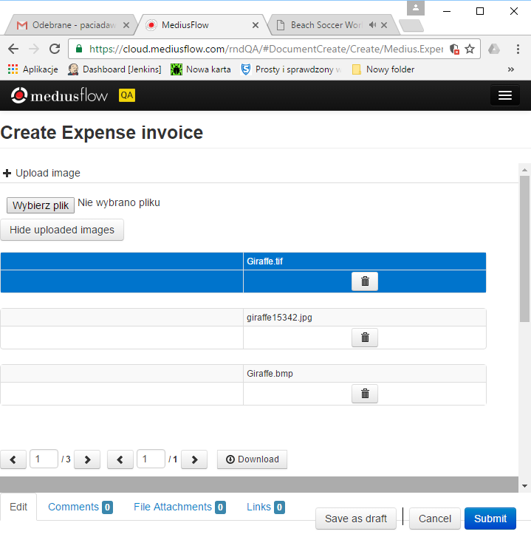
A list of further testing areas that you would want completed before you would be comfortable
shipping this feature to production instances. Consider the risks of the feature as you understand it.
At first I would gather at least minimal requirements from customer/stakeholder. But in such situation it has to be for sure checks as the feature of Create Expense invoice functionality so integration testing. That's also not really clear what is for example the average number of customers so it's hard to estimate risk and prioritize the performance testing issue. There are also some very basic security issues worth checking. And, the last but not least, backend is now untouched from testing point of view so it also should has been done.

